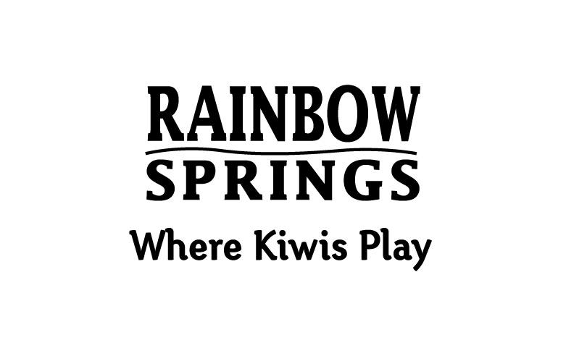
News Release

The Big Splash will 'wow' conference groups
Rotorua, 1 June, 2012 – Take your conference delegates on a inspirational and thrilling journey through time on Rainbow Springs' Big Splash ride.
The Rotorua park's new multi-million dollar attraction is available for exclusive group hire after 5pm and guaranteed to 'wow' conference delegates.
Kat Hicks, Rainbow Springs Event Manager says, "The Big Splash is a nine-minute narrated journey through time and the ecological evolution of New Zealand. The ride features state-of-the-art animation bringing to life dinosaurs, moa and the haast eagle, and an adrenalin boosting plunge at the end."
She says that the ride is a thrilling addition to the park and by offering groups exclusive hire it adds an extra special touch to a conference itinerary.
"The Big Splash could be preceded with a cocktail function at the newly extended Wairere Cafe, which is near The Big Splash queuing race and splash-down viewing area. It's also adjacent to the picturesque Waterfall Lakes area, which when illuminated at night looks stunning."
The park also has some other special places for functions including a lawn adjacent to the cafe big enough to accommodate a marquee and a 384 covered tiered seating outdoor arena suitable for an outdoor show.
The Big Splash opened to the public in late January and more than 4,000 boat loads of riders have experienced the Big Splash since its inaugural trip.
The traditionally busy Easter and school holiday period in April this year saw park visitor numbers skyrocket and nearly triple compared to April 2011, the rise directly attributable to the addition of the Big Splash.
As expected the Big Splash is becoming a major drawcard for Rotorua, giving international and local visitors an exciting and unique insight into New Zealand history and culture.
Rainbow Springs is an icon of New Zealand tourism and has been open since 1932. Spread over 22 acres of Rotorua parkland, Rainbow Springs is a conservation and breeding haven for endangered New Zealand species such as Kiwi and tuatara. The park offers a unique wildlife experience for visitors, who can see animals in their natural environment, both during the day and night. Features of the award winning tourist attraction include New Zealand’s first ‘open to view’ Kiwi hatchery, and a range of wildlife including trout, tuatara and native birds.
Rainbow Springs, Fairy Springs Road, Rotorua
www. rainbowsprings.co.nz

